Classification
Classification systems are used to organize information. In biology, for example, they are used to distinguish specific types of organisms. Most systems of classification use standard principles of organization, where data is divided into the broadest categories and then organized into subgroups.
Look at each fingerprint below. Criminologists use a system for classifying fingerprints to make it easier to compare. What categories would you divide them in to? What subcategories?
 | 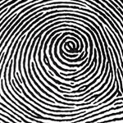 | 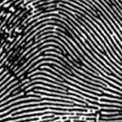 | 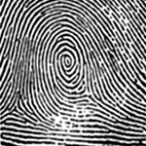
 | 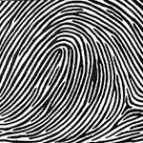 | 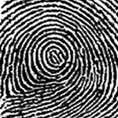 | 